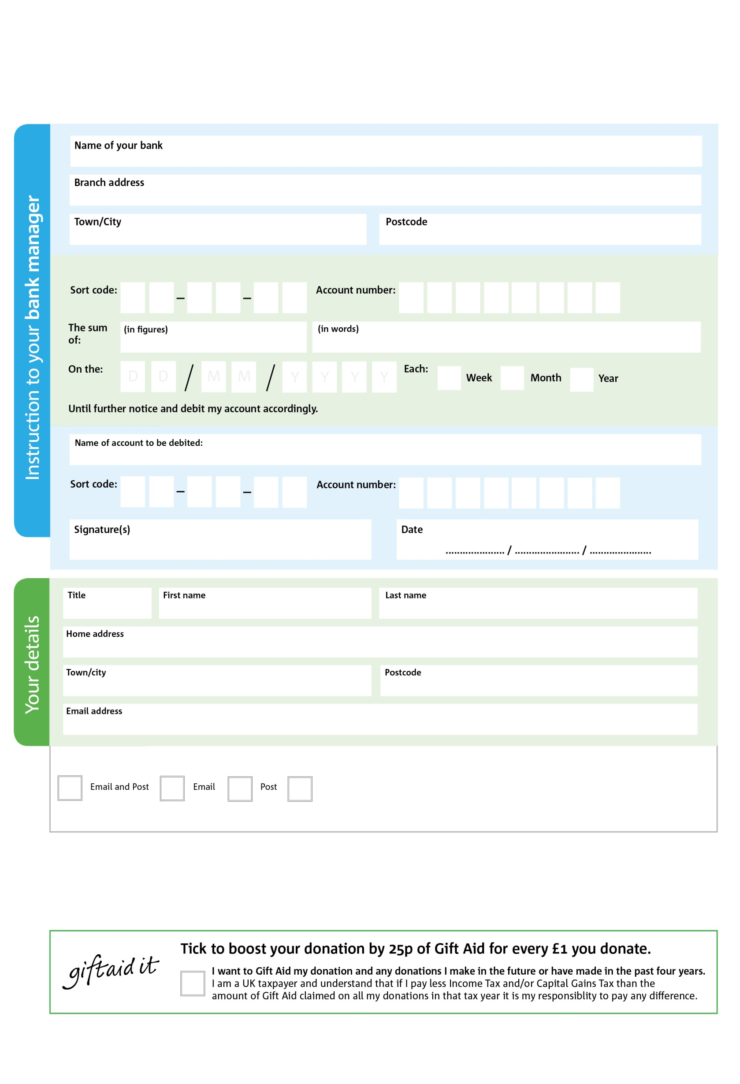

You can change your preferences any time by contacting us on 0174426414 or emailing us at [info@sthelens.foodbank.org.uk](mailto:info@sthelens.foodbank.org.uk) or info@hopecentre.org.uk

We would love to keep you up to date with information about St Helens Foodbank. Please tick your preference:

**Please pass this form onto the Hope Centre, using the charity’s address at the bottom, who will save a copy for their records.   
They will then send it onto your named bank or building society.**

The Hope Centre is registered in England and Wales as Charity Number 1103903 and a Company Ltd by Guarantee No 05089663

Please pay The Hope Centre – St Helens,

POSTAL ADDRESS: The Hope Centre, Atherton ST, St Helens, Merseyside, WA10 2DT

2

V

4

V

5

V

9

V

1

V

5

V

0

V

7

V

4

4

7 7

0

5

0

I do not wish to receive future communications from St Helens Foodbank

**Data protection**

*‘The Hope Centre St Helens is committed to protecting your privacy and will process your personal data in accordance with current Data Protection legislation. The Hope Centre St Helens collects information to keep in touch with you and supply you with information relating to our work. To unsubscribe from our newsletter, send a message to the email address above with the word unsubscribe in the subject line. A full data privacy statement for financial donors is available from The Hope Centre on request.’*

**Standing Order Mandate**

**St Helens.foodbank.org.uk**

You can change your preferences any time by contacting us on XXXXXXXXXXX or emailing us at XXXX@XXXXXXXXXX.foodbank.org.uk

I do not wish to receive future communications from XXXXXX Foodbank