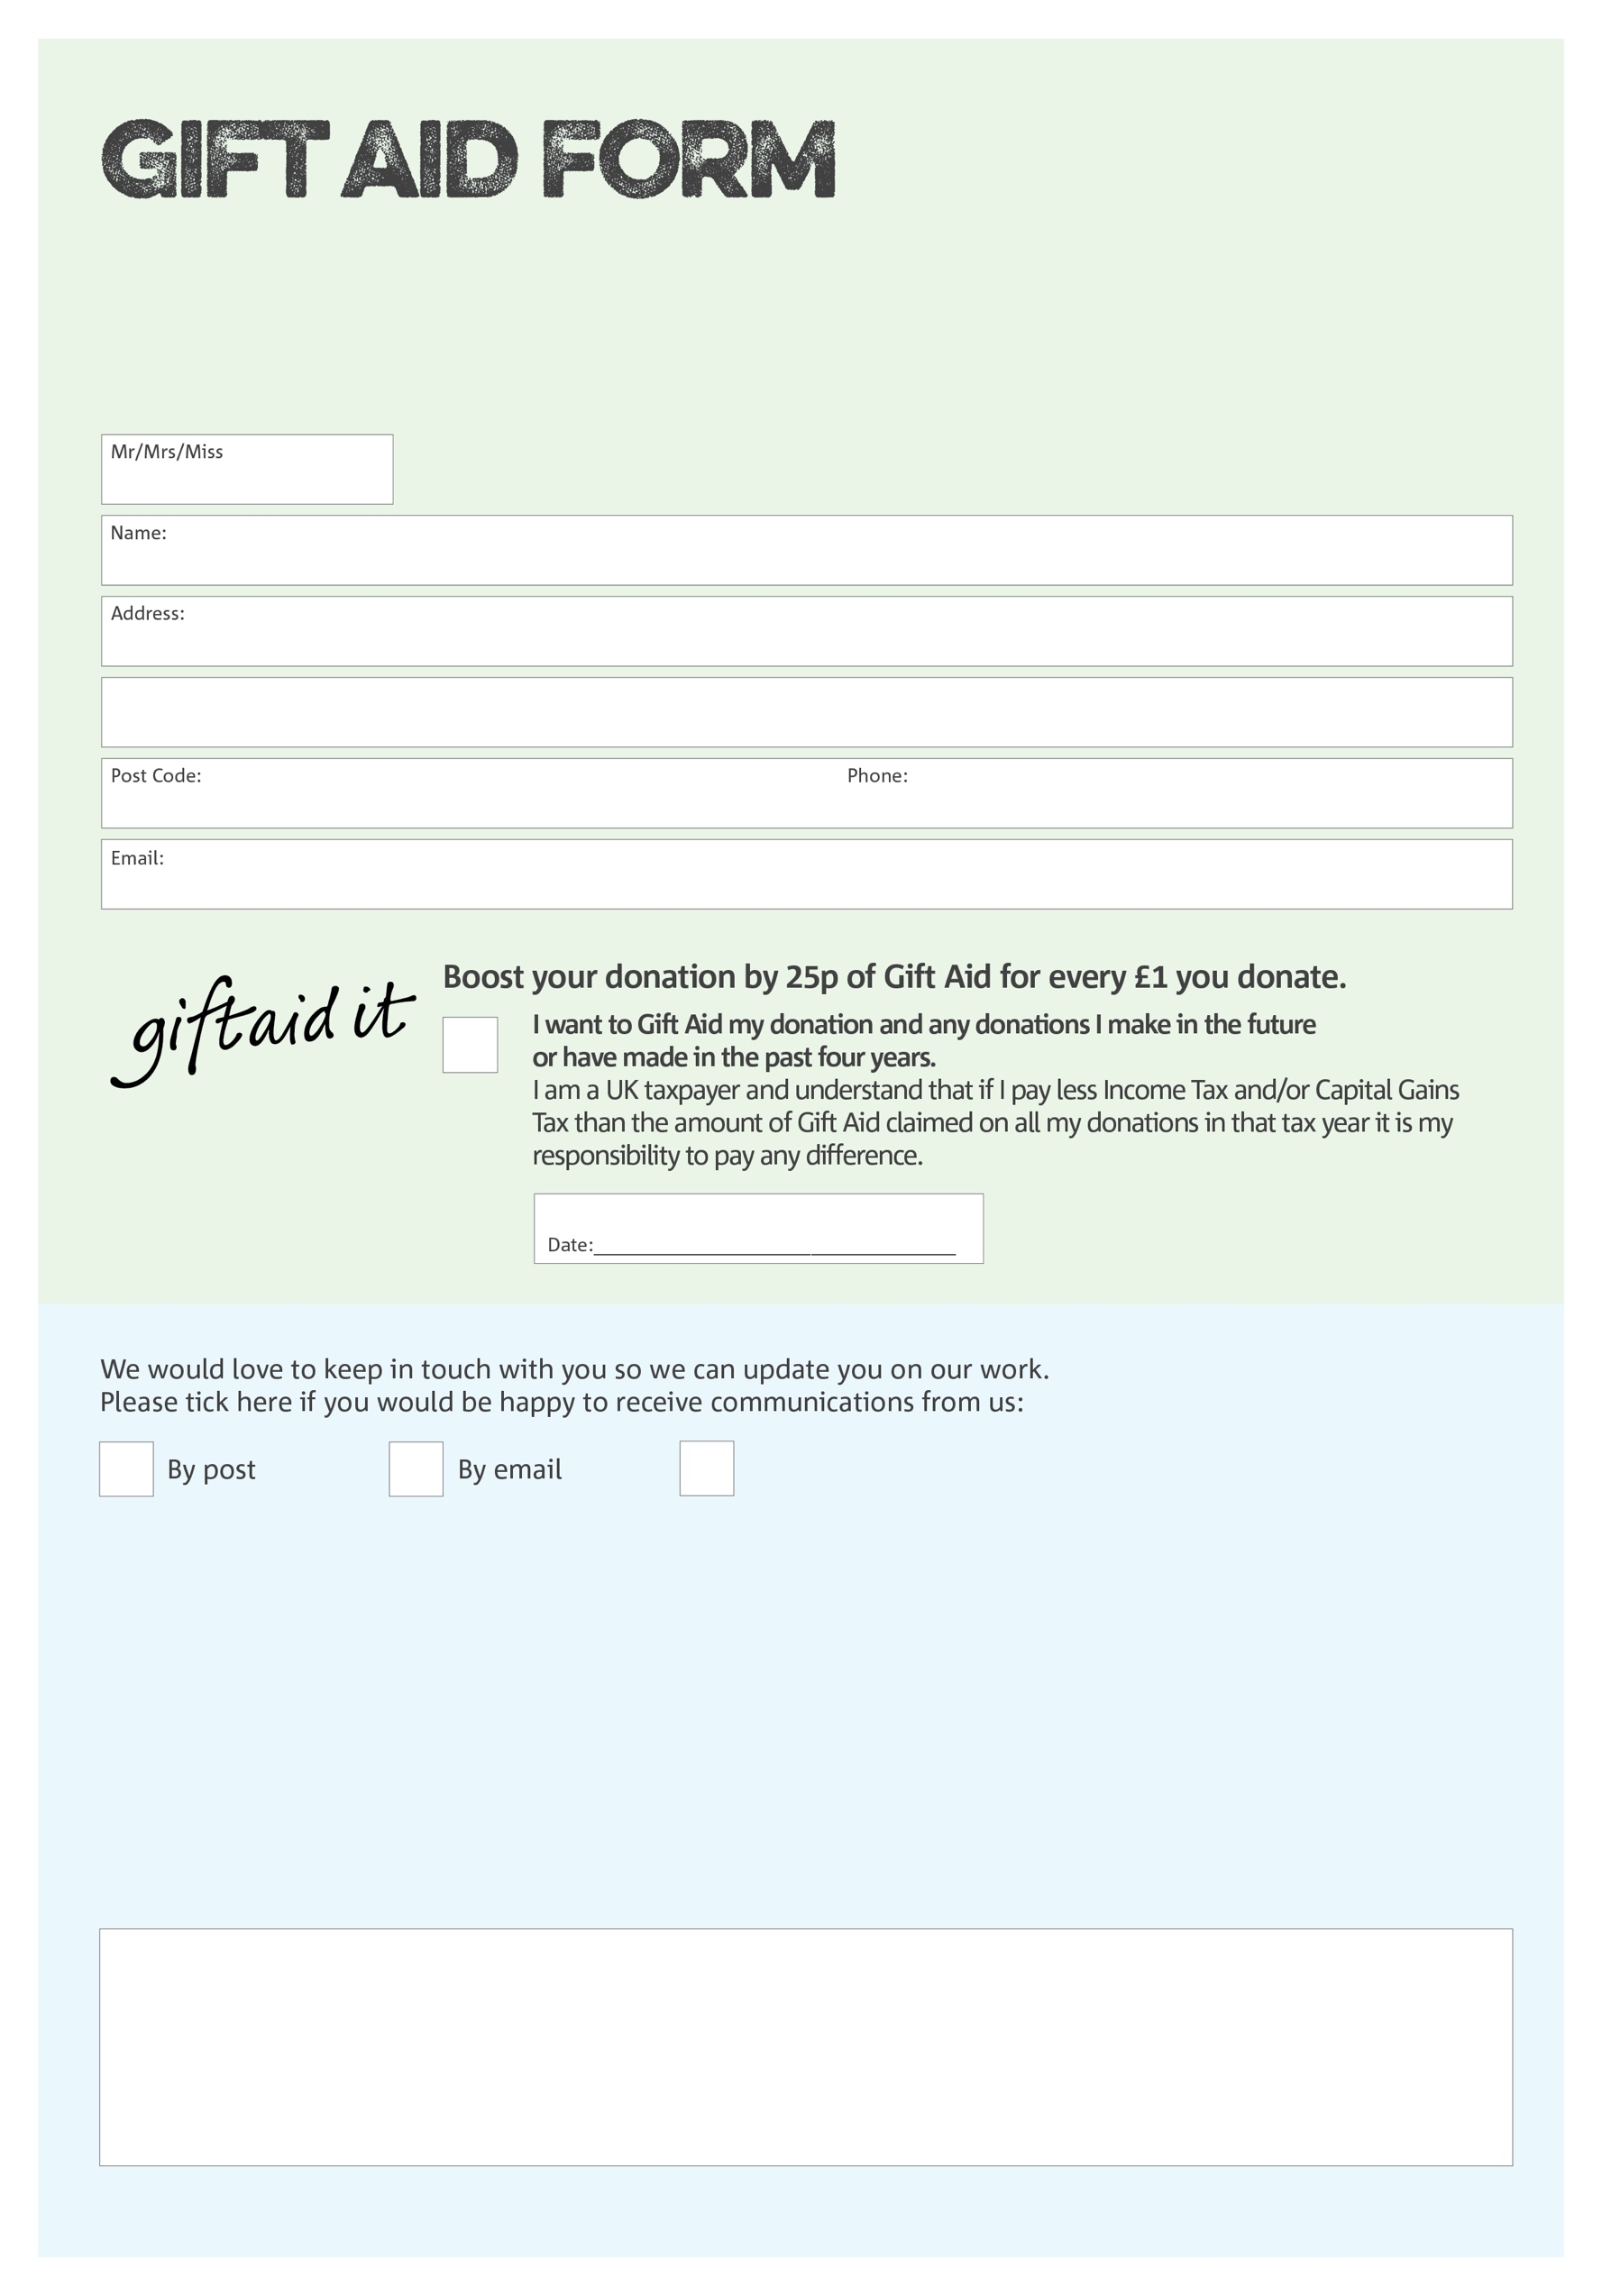

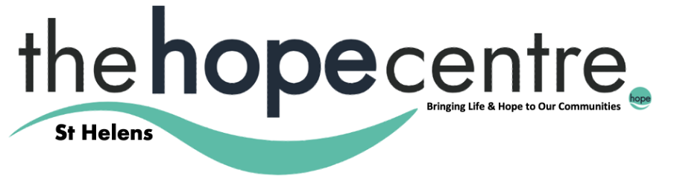

**Single Donation**

By filling in this form, St Helens Foodbank will receive an extra 25p for every £1 you give at no extra cost to you. Thank you!

We would love to know why you have chosen to support to St Helens Foodbank. If you would like to share your motivation let us know below:

The Hope Centre is registered in England and Wales as Charity Number 1103903 and a Company Ltd by Guarantee No 05089663

**Data protection**

*The Hope Centre and St Helens Foodbank is committed to protecting your privacy and will process your personal data in accordance with current Data Protection legislation. The Hope Centre collects information to keep in touch with you and supply you with information relating to our work.*

*To unsubscribe from our newsletter, please send a message to the email address above with the word unsubscribe in the subject line.*

*A full data privacy statement for financial donors is available from The Hope Centre on request.*

You can change your preferences any time by contacting us on 0174426414 or emailing us at

[info@sthelens.foodbank.org.uk](mailto:info@sthelens.foodbank.org.uk) or info@hopecentre.org.uk

I do not wish to receive future communications from St Helens Foodbank and its parent charity The Hope Centre - St Helens